|  |  |  |  |
| --- | --- | --- | --- |
| Process Title | O2C Errors: Service Cloud Report Reformatted | | |
| Affected Department | Customer Service, Logistics | | |
| Process Owner |  | | |
| Initial Document Creation Date | 2/16/2023 | Last Revision Date |  |

Contents

Document Purpose 2

Process Instructions 2

Creating Report View 2

Exporting Report for the Previous Month 4

Reformatting Excel Report 5

Sending the Report 9

Python Script Automation 10

Revision History 14

***Note:*** *Update Table of Contents after making changes so that page numbers are reflected correctly.*

# Document Purpose

This document describes how to create the report view, export the report, and reformat the Excel output for the O2C Accuracy Tracking process.

# Process Instructions

## Creating Report View

1. Open Service Cloud report **CS_NAM_Survey_Results** (under Analysis tab > Reports)
2. In the Selection panel on the right, under Question Description, click on the box to select more questions

1. Check off **all** the following questions and click OK. Run updates.



1. Scroll down in the Selection panel and delete the Customer Service Catalog from the Service Category Catalog and Incident Category Catalog by clicking on the X

1. In the View panel on the right, rearrange and add the row fields to follow below:

To add fields

1. Under Settings, toggle on the “Display Repeated Texts” and Click Apply Settings

1. Save As > New Selection > Rename to “ManagerSurvey (O2C)” > Click Save

1. Now your report view is set up and saved!

## Exporting Report for the Previous Month

1. Open Service Cloud report **CS_NAM_Survey_Results** (under Analysis tab > Reports)
2. Select the saved view “ManagerSurvey (O2C)”

1. Click on Filter and click on the box for Reported On Date

1. Select all of the dates for the previous month **(Note: The date is in “dd.mm.yyyy” format)**
2. Click on Run with Filter
3. Download to Microsoft Excel

## Reformatting Excel Report

1. Open the downloaded Excel file. Click Enable Editing
2. Rename the tab to “Export”
3. Select the whole sheet by clicking the top left corner. Adjust the columns width so that they’re smaller

1. Click on any cell within the table and select Filter

1. Filter the “Question Description” column to “What was the detailed cause of the issue…” questions

1. Change all the cells to “What was the detailed cause of the issue?” by changing the first row and double clicking the plus sign that appears on the bottom right corner of the cell

1. Copy all of the cells in the “Question Description” column and paste it into a new tab renamed to “Questions”
2. With all the cells selected, go to Data > Remove Duplicates and Click OK. This is the list of questions

1. In the data of “Export” tab, add a new column “Key Indicator” next to the Ticket # and enter the following formula: **=B15&G15**. Drag down the formula by double clicking on the bottom right corner of the cell

1. Add a new column “Answer” next to Survey Answer Text and enter the following formula: **=IF(H15<>”#”,H15, I15).** Drag down the formula by double clicking on the bottom right corner of the cell

1. Copy and paste the entire table into a new tab. Delete the Key Indicator, Question Description, Survey Answer, Survey Answer Text, and Answer columns (columns should be as shown below)



1. Rename the tab to “Final Data.” Select the whole table, go to Data > Remove Duplicates and Click OK
2. Insert number of columns based on the number of unique questions (7) next to Ticket #. Right click on the column > Insert

1. Copy the list of questions and paste as Transpose into the inserted column headers

1. In cell C2, enter the following formula: **=IFERROR(VLOOKUP($B2&C$1,Export!$C:$J,8,FALSE),””)**. Click on the bottom right of the cell and drag the formula to the right so that you get an answer for all of the questions

1. Then, with the first row of answers selected, drag down the formula by double clicking on the bottom right corner of the cell

1. Add in column names for “Ticket #” and “Account #” (below are all of the column headers)



**…**  

1. Select the whole table (CTRL + A) and copy and paste as Values

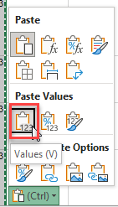

1. Add a key to indicate data from the Manager Survey and from the CF Ticket (as shown below)



… 

1. Select all the data in the “Final Data” tab, go to Insert > Pivot Table. Rename the tab as Pivot”
2. Add the following attributes to the Rows and Values:

1. Copy and paste the pivot table onto the same tab and add the second question:

1. These are your final pivot tables:

1. Rename the excel file as “O2C Year-Month Full”
2. Here is an example file: [O2C Report Reformatted Example.xlsx](https://stgcs.sharepoint.com/:x:/r/sites/US01_P_NAMOps/Shared%20Documents/O2C%20Accuracy/SWI%27s%20and%20Training%20Files/O2C%20Report%20Reformatted%20Example.xlsx?d=w38c0a700faef4e02876efcf53be53613&csf=1&web=1&e=az62Mi)

## Sending the Report

1. Email the report to the following individuals:
   1. Shawn Steed
   2. Hannah Marollo
   3. Catherine Barbaro
   4. John Gastaldo
   5. Gabrielle Panacopoulos
   6. Paula DiFrancesco
   7. Dan Zaccardi (Dan has left, need to identify who will cover Logistics)
   8. Manuja Jain
   9. Arnas Gasparonis
   10. Zili Huang
   11. Praveen Kusuma
   12. Jahan Saffari
2. Attach the file and add the Responsible Party pivot table

## Python Script Automation

1. Install Python in your machine through below website:

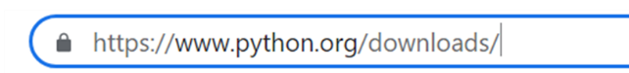

1. Go to Downloads and click on Windows:

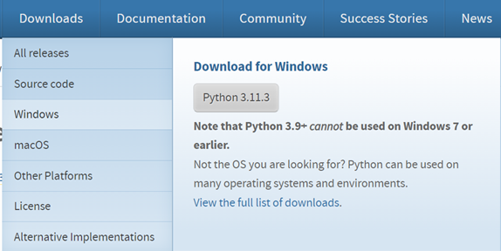

1. Click on highlighted link:

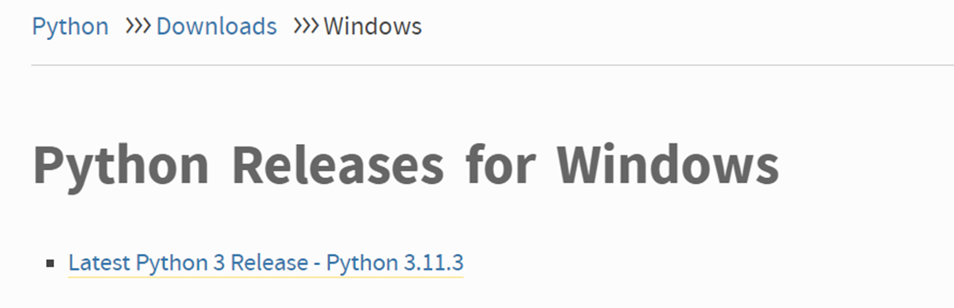

1. Click on Installer to download as per your system specifications (Windows or macOS)

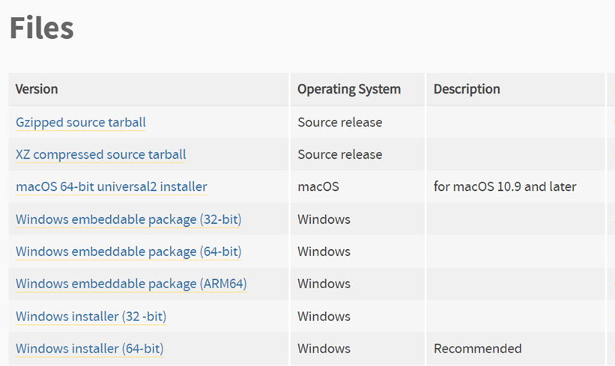

1. Once downloaded, click on .exe file:

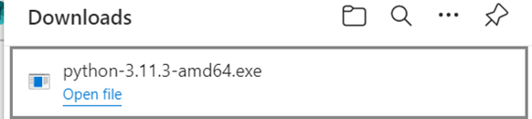

1. Click on Install now:  
   Please uncheck the option “Use admin privileges when installing py.exe”

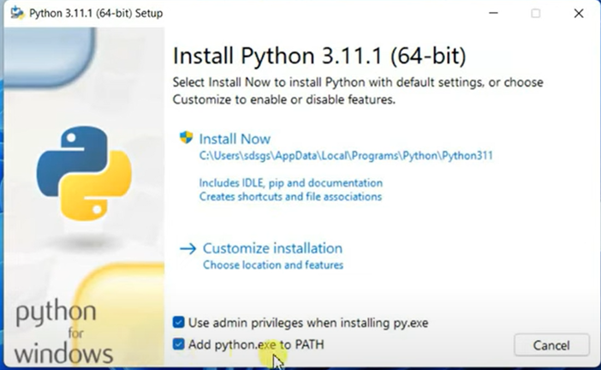

1. Once downloaded, open Command Prompt from windows search box.

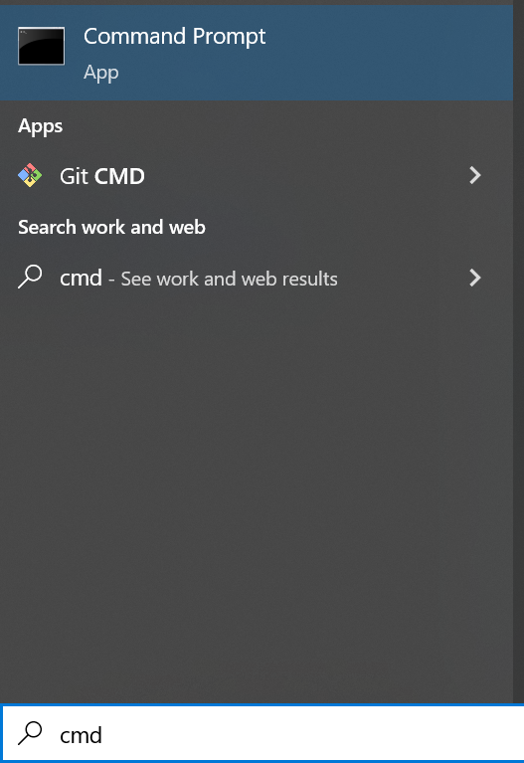

1. Type “python –version” to check if python successfully installed or not.

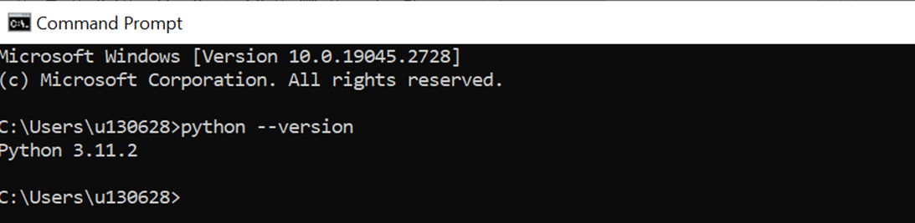

1. Open IDLE from Windows search box:

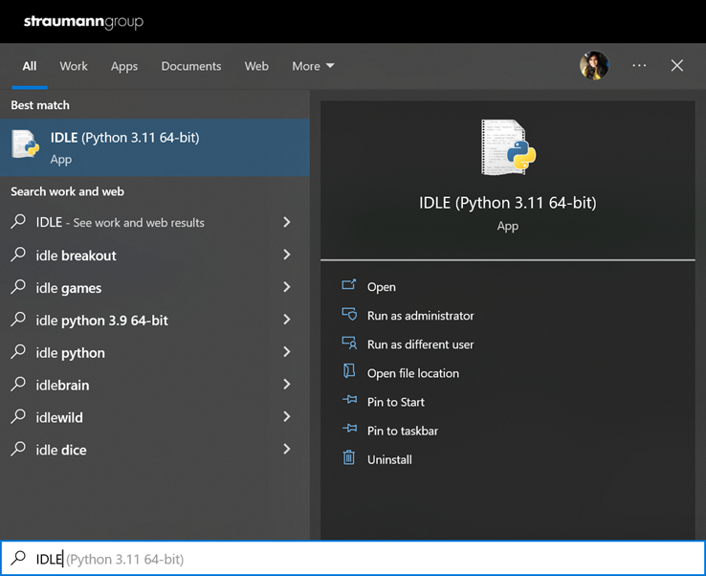

1. Go to File > Open > O2C_Reform_Columns.py file.

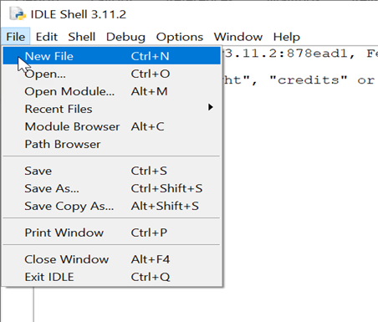

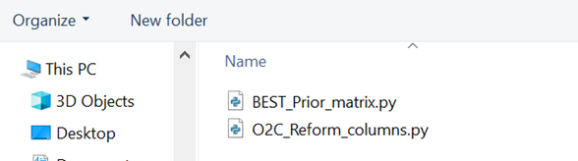

1. Change the path as per the folder you have saved your excel file in:
2. Go to Run > Click Run Module to run the script.

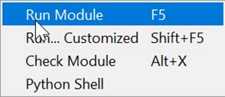

1. A new excel file “O2C_Updated” will be downloaded in the folder mentioned in the script.

# Revision History

|  |  |  |  |
| --- | --- | --- | --- |
| Revision | Name | Date | Changes Made |
| A | Angela Tsuei | 2/16/2023 | Document created (Creating Report View and Exporting Report for Previous Month Processes) |
| B | Angela Tsuei | 2/21/2023 | Added Reformatting Excel Report Process |
| C | Angela Tsuei | 3/9/2023 | Added note that question “What was the detailed cause of the issue (Order Call Flow-CS, SS, DSO)” cannot be added to the report |
| D | Angela Tsuei | 4/6/2023 | Natacha updated the question “What was the detailed cause of the issue (Order Call Flow-CS, SS, DSO)” to “What was the detailed cause of the issue” so now it can be added to the report. Added the question to be selected in creating the report view and deleted the note that was added in previous update. |
| E | Angela Tsuei | 4/12/2023 | Added more details to preparing the report (steps 19-25) and added section for Sending the Report. |
| F | Manuja Jain | 4/24/2023 | Python Script Automation Updated |
|  |  |  |  |
|  |  |  |  |
|  |  |  |  |